# **Purification of Methanol**

Submitted By: Priyanshu Maurya

Roll No.: 220827

TA: Praful Mane

## **AIM**

The goal of the laboratory session is to:

1) Determine the total molar flow rate of all the streams and the mole fractions of streams 4a and 5a.

2) Make a plot of the total capital cost of separation equipment as a function of product flow rate (stream 7).

## **METHOD**

**Approach 1**: We first assign variables to different molar rates at each process as shown below,

**Approach 2**: To find degree of freedom:

Number of variables = 4

Number of mass balance equations = 4

Therefore, degree of freedom = (Number of variables) – (Number of mass balance equations)

= 4-4

= 0

**Approach 3**: Using appropriate mass and energy balances, we can form equations as follows:

n7 = 893.263 kmol/hr

0.176(n3) – 0.243(n4) – 0.744(n5) = 0.002(n7)

0.53(n3) – 0.752(n4) – 0.027(n5) = 0

0.147(n3) – 0.004(n4) – 0.188(n5) = 0.987(n7)

0.147(n3) – 0.001(n4) – 0.041(n5) – n6 = 0.011(n7)

**Approach 4**: We have the following matrix equation. Using MATLAB function linsolve, we will solve for n3, n4, n5, &n6

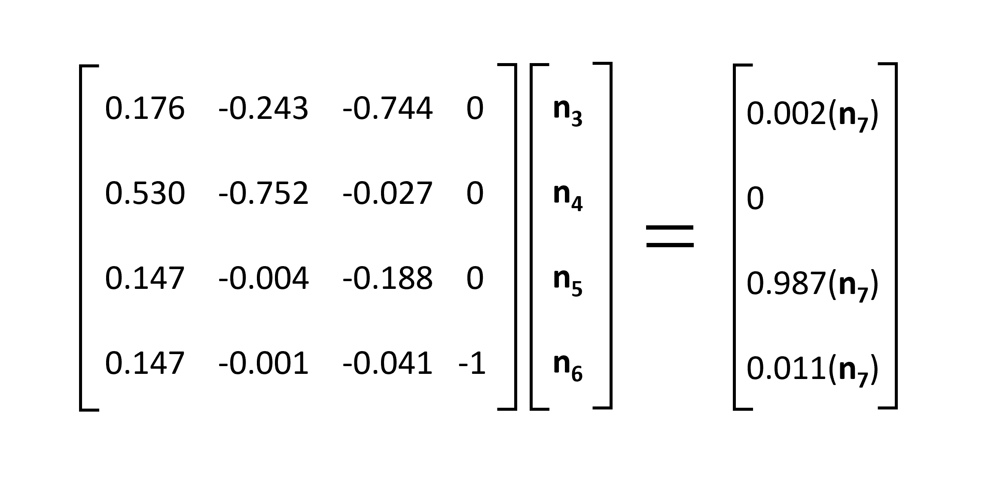

**Approach 5**: Assigning variables to mole fractions of streams 4a and 4b:

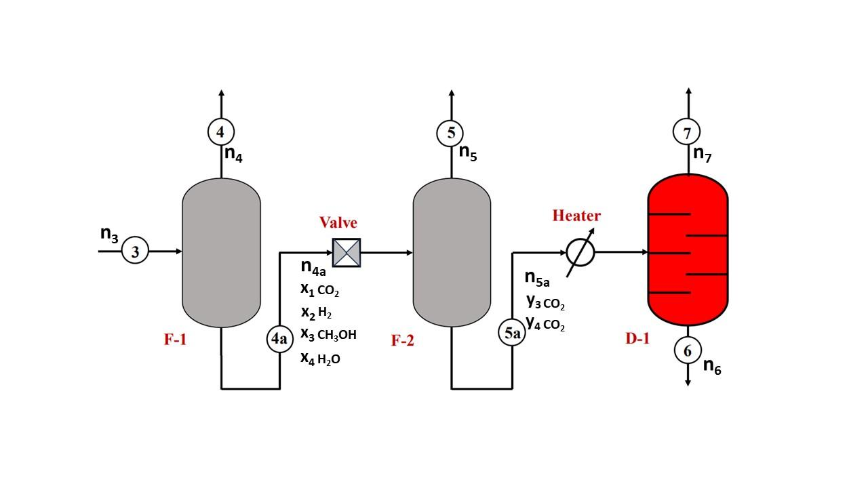

**Approach 6**: After getting n3 n4 n5 n6 , solving for n4a and n5a :

n3 = n4 + n4a

n5a = n7 + n6

**Approach 7**: Solving for x1, x2, x3, x4, y3, and y4 using equations below in MATLAB:

x1 = ((0.176* n3) - (0.243* n4))/ n4a;

x2 = ((0.53* n3) - (0.752* n4))/ n4a;

x3 = (0.147* n3)/ n4a;

x4 = (0.147* n3)/ n4a;

y3 = (0.987* n7)/ n5a;

y4 = n6 / n5a;

## **RESULTS AND ANALYSIS**

After solving using linsolve in MATLAB we get:

n3 = 6163.5 kmol/hr

n4 = 4342.6 kmol/hr

n5 = 37.3 kmol/hr

n6 = 890.3 kmol/hr

n4a = 1820.9 kmol/hr

n5a = 1783.6 kmol/hr

Mole fractions of stream 4a :

mole fraction of CO2 = 0.0162

mole fraction of H2 = 0.00055

mole fraction of CH3OH = 0.4976

mole fraction of H2O = 0.4976

Mole fractions of stream 5a :

mole fraction of CH3OH = 0.4943

mole fraction of H2O = 0.4992

The plot of the total capital cost of separation equipment as a function of product flow rate

(stream 7) is shown below:

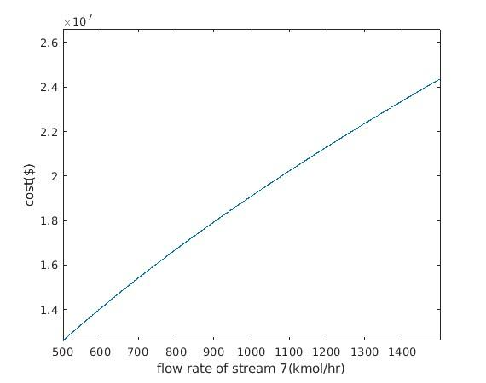

## **CONCLUSION**

We got the molar flow rate for all the processes. And we also verified the value obtained from linsolve, using Gauss Elimination.

## **APPENDIX**

The MATLAB code to solve the problem is as follows:

n7= 893.263;

cf1= [];

cf2= [];

cd1= [];

cost = [];

x= [];

A=[0.176 -0.243 -0.744 0;

0.53 -0.752 -0.027 0;

0.147 -0.004 -0.188 0;

0.147 -0.001 -0.041 -1];

b = [0.002*n7;

0;

0.987*n7;

0.011*n7];

% using linsolve function to solve matrix equation

n= double(linsolve(A, b));

n4a = n(1)-n(2);

n5a = n(4) + n7;

x1 = ((0.176*n(1)) - (0.243*n(2)))/n4a;

x2 = ((0.53*n(1)) - (0.752*n(2)))/n4a;

x3 = (0.147*n(1))/n4a;

x4 = (0.147*n(1))/n4a;

y3 = (0.987*n7)/n5a;

y4 = n(4)/n5a;

% plotting capital cost as function of inlet flow rate

for i = 500:1500

m = i-499;

f3 = i*(0.987/0.147);

f4a = f3*(0.147/0.4976);

f5a = i*(0.987/0.4943);

cf1(m)= 182100*((f3/n(1))^(0.6));

cf2(m)= 171200*((f4a/n(2))^(0.6));

cd1(m)= 1725400*((f5a/n(3))^(0.6));

cost(m) = cf1(m)+cf2(m)+cd1(m);

x(m) = i;

end

plot(x, cost)